BINARY SEARCH:  
#include <stdio.h>

int binary(int a, int arr[], int n) {

int M = 0, N = n - 1, mid;

while (M <= N) {

mid = M + (N - M) / 2;

if (arr[mid] == a) {

return mid;

} else if (arr[mid] < a) {

M = mid + 1;

} else {

N = mid - 1;

}

}

return -1;

}

int main() {

int n, x;

printf("Enter number of elements in the array: ");

scanf("%d", &n);

int arr[n];

printf("Enter elements of the array in sorted order: ");

for (int i = 0; i < n; i++) {

scanf("%d", &arr[i]);

}

printf("Enter the element to be searched: ");

scanf("%d", &x);

int z = binary(x, arr, n);

if (z != -1)

printf("Element found at index: %d\n", z);

else

printf("Element not found\n");

return 0;

}

OUTPUT :  
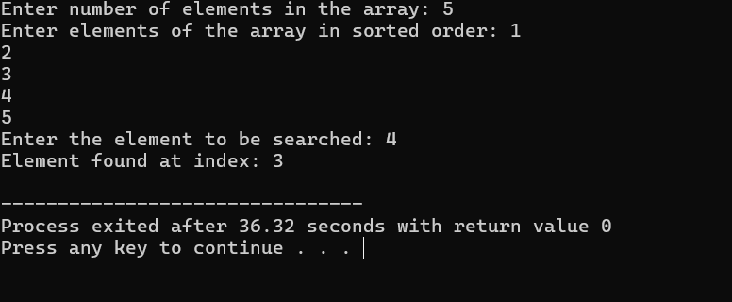

LINEAR SEARCH:  
#include<stdio.h>

int linear( int arr[],int a, int n){

for(int i = 0; i < n; i++){

if(arr[i] == a){

return i;

}

}

return -1;

}

int main(){

int n;

printf("enter number of elements of an arraay: ");

scanf("%d", &n);

int arr[n];

printf("enter elements of array: ");

for(int i = 0; i < n; i++){

scanf("%d", &arr[i]);

}

printf("eneter the element to be searched: ");

int a;

scanf("%d", &a);

int z=linear(arr, a, n);

if(z != -1) {

return printf("element found at index: %d\n", z);

} else {

return printf("element not found\n");

}

}

OUTPUT:  
